1.CEASER CIPHER USING PYTHON

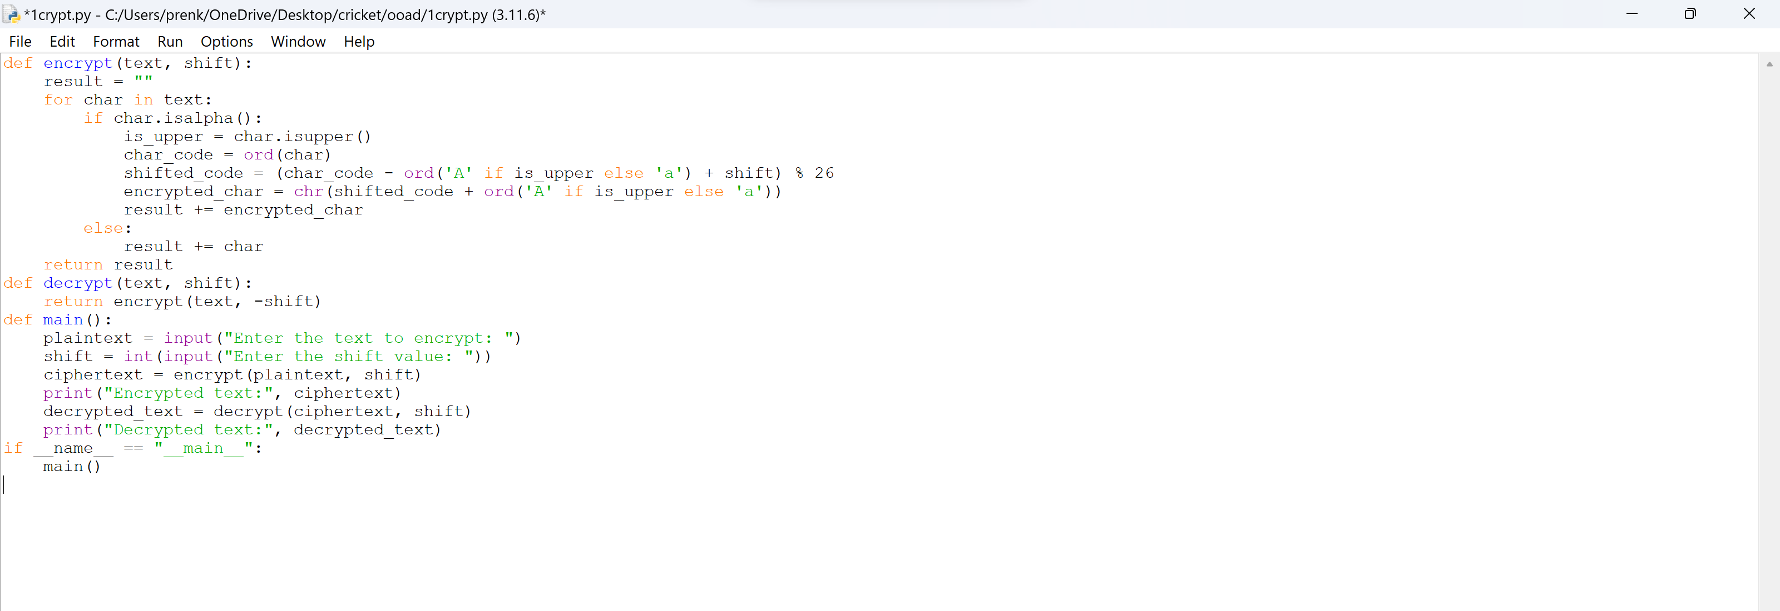

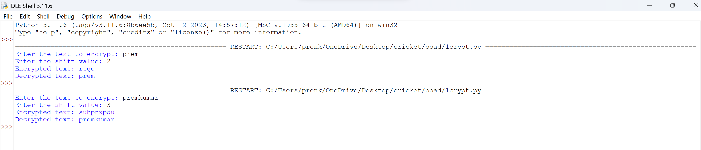

2.MONOALPHABETIC SUBSTITUTION CIPHER

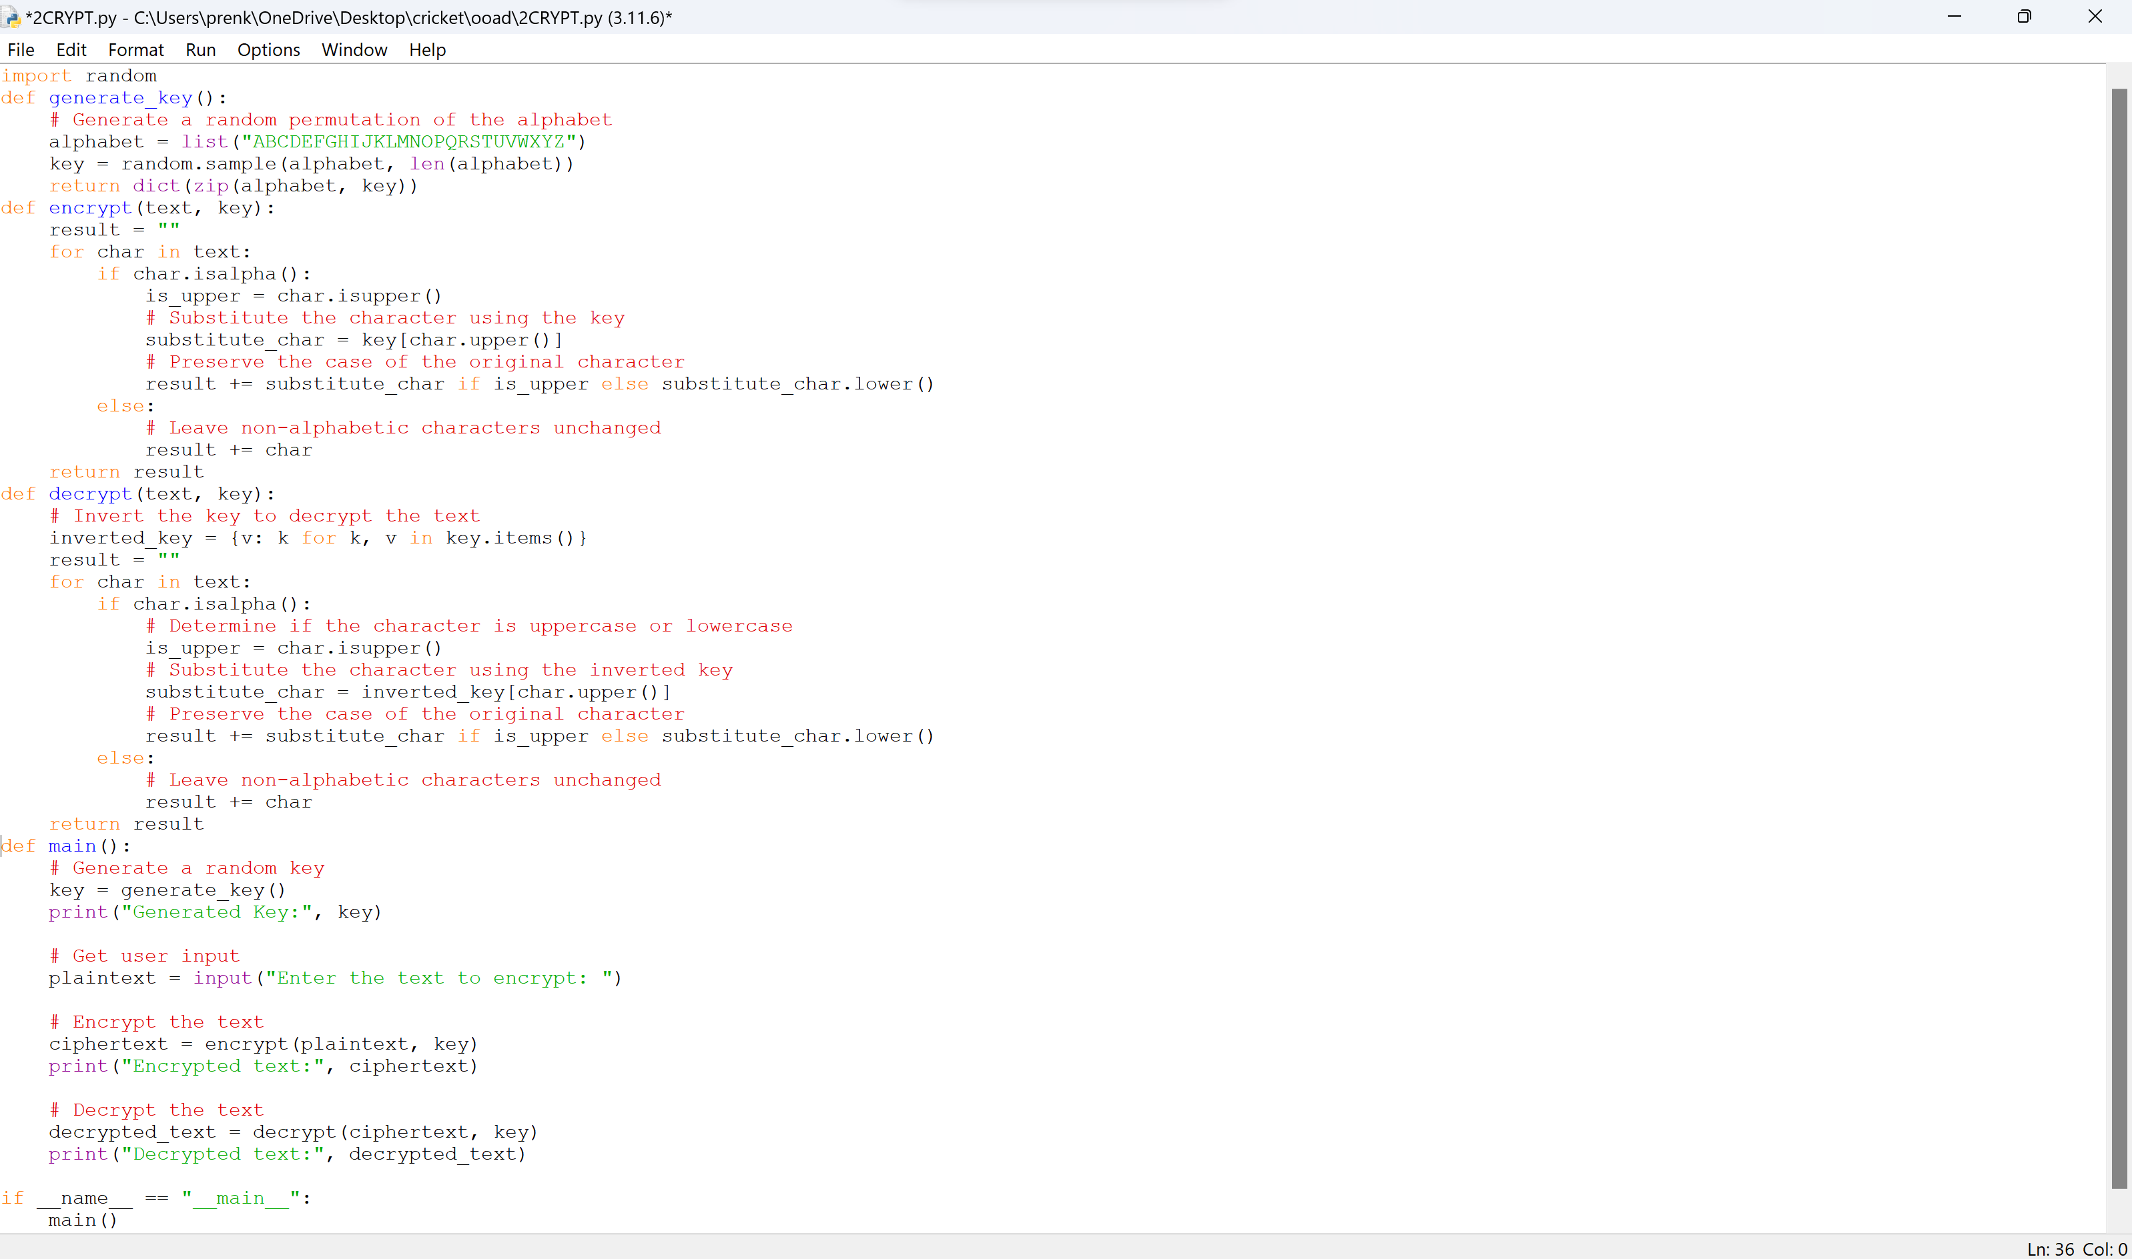

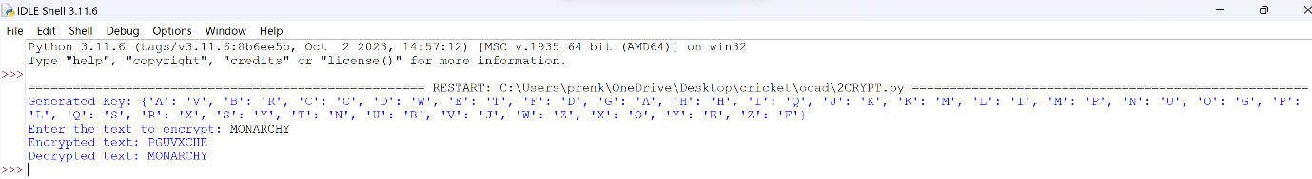  
3.PLAYFAIR CIPHER USING PYTHON

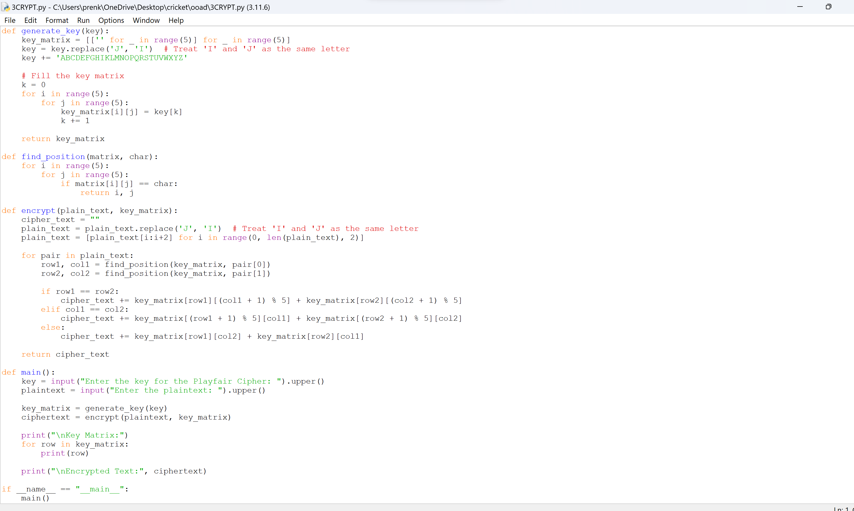

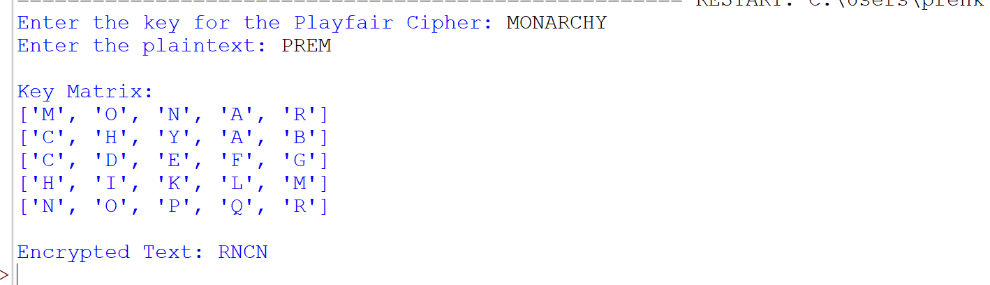

4.POLYALPHABETIC CIPHER

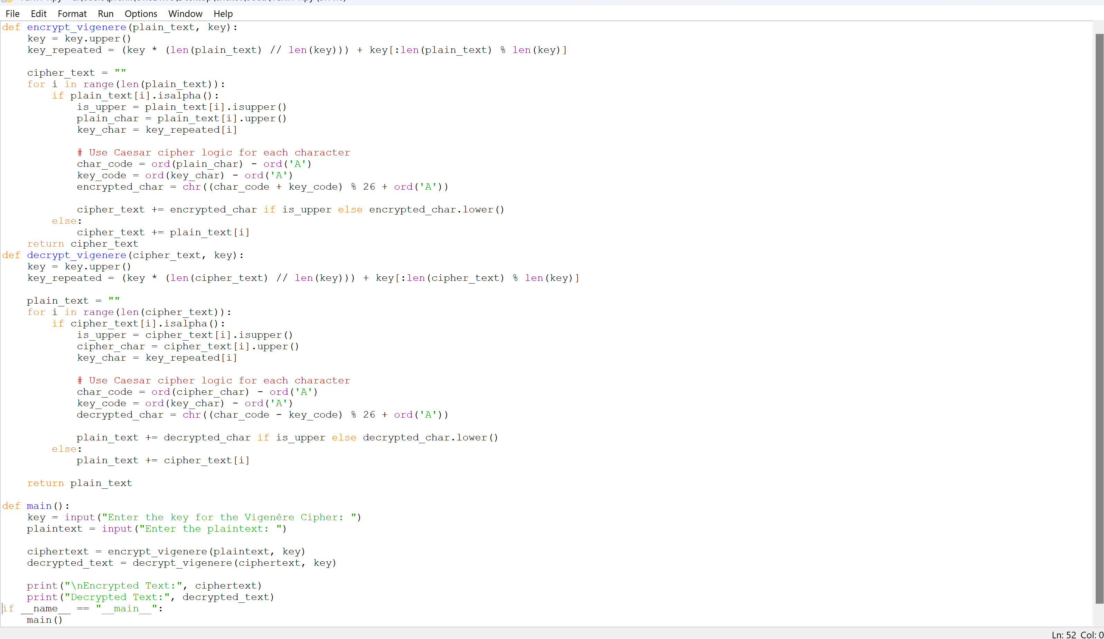

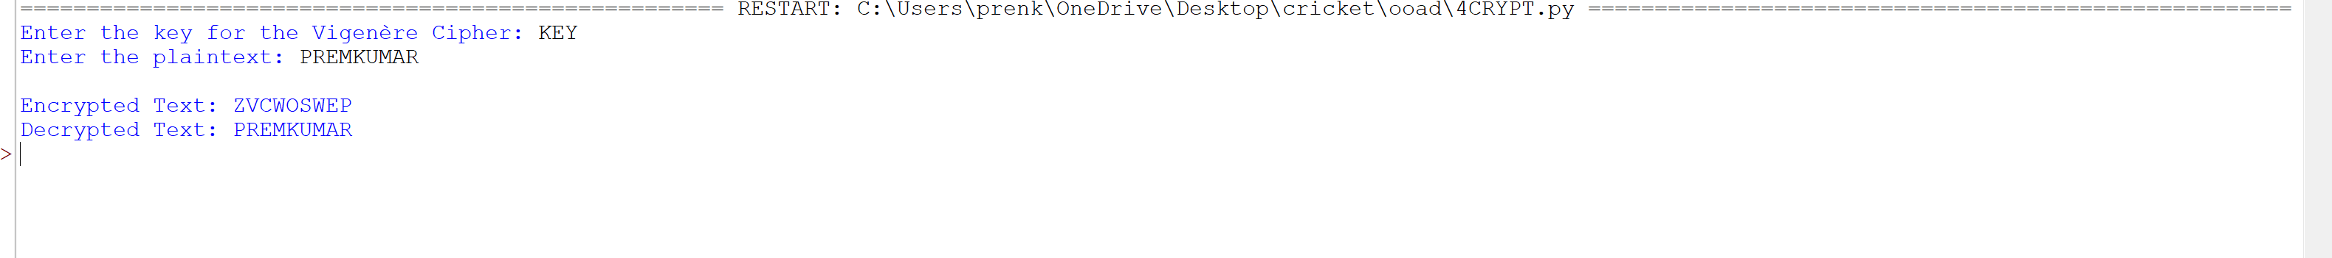

5.CONVERSION OF CIPHER TEXT USING PYTHON PROGRAM

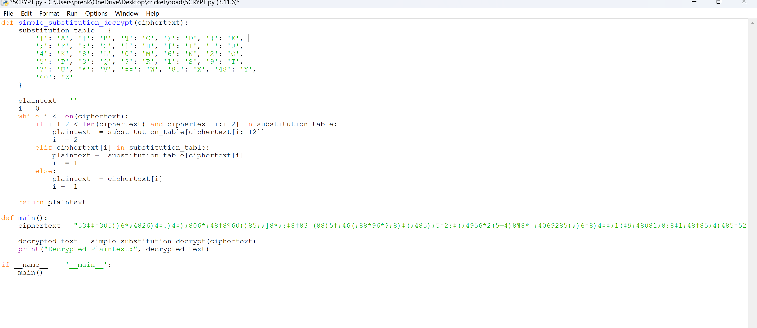



6.VEIGNERE CIPHER

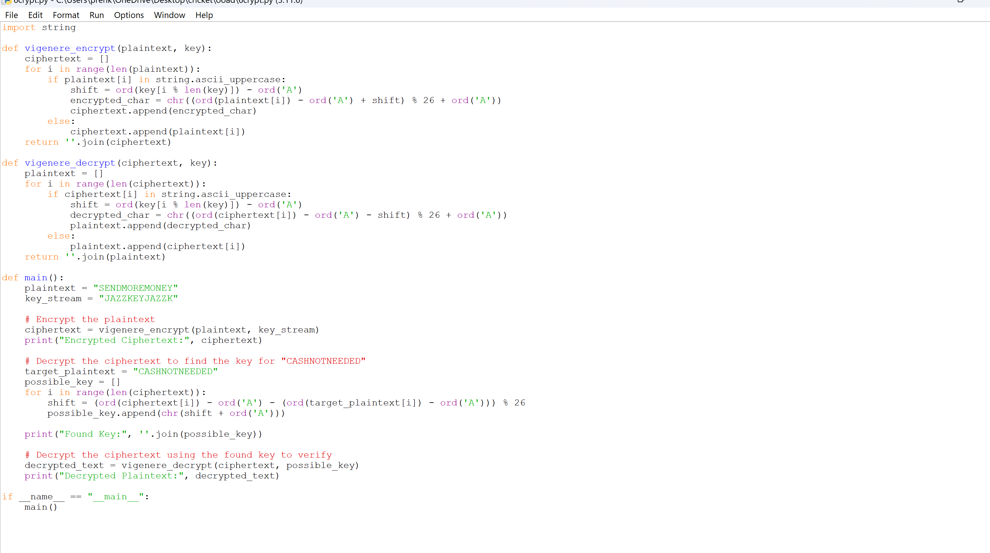



7.ADDITIVE CIPHER USING PYTHON

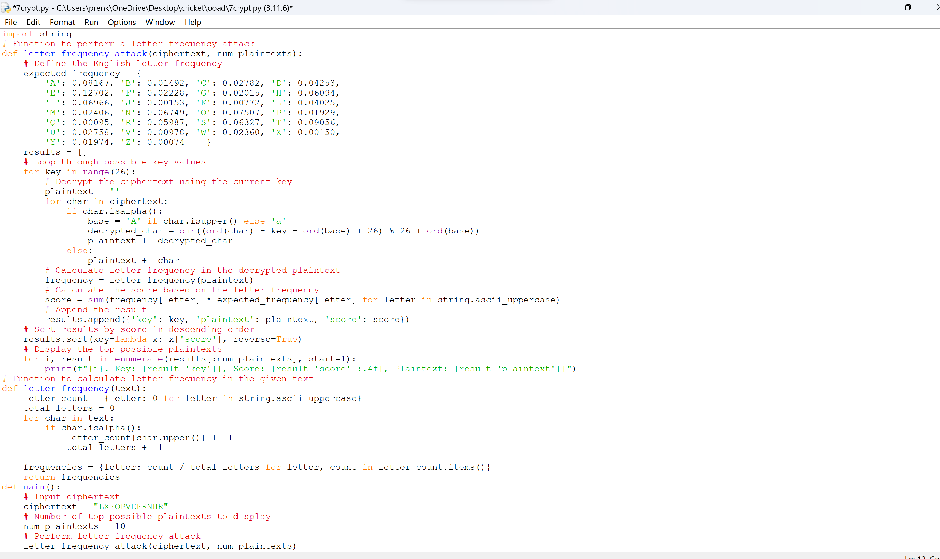

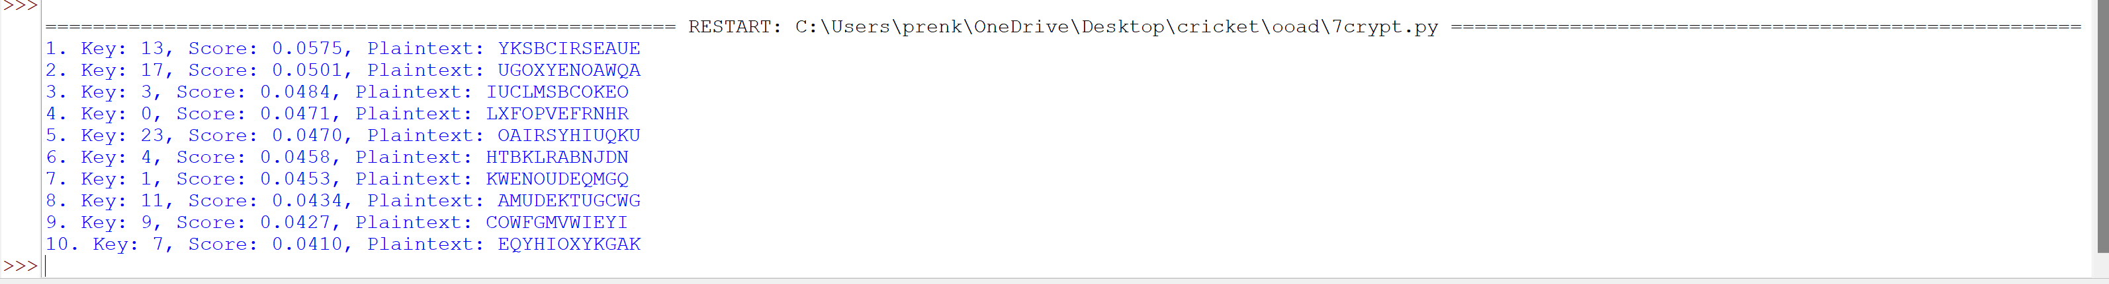

8.AFFINE CIPHER USING PYTHON PROGRAM

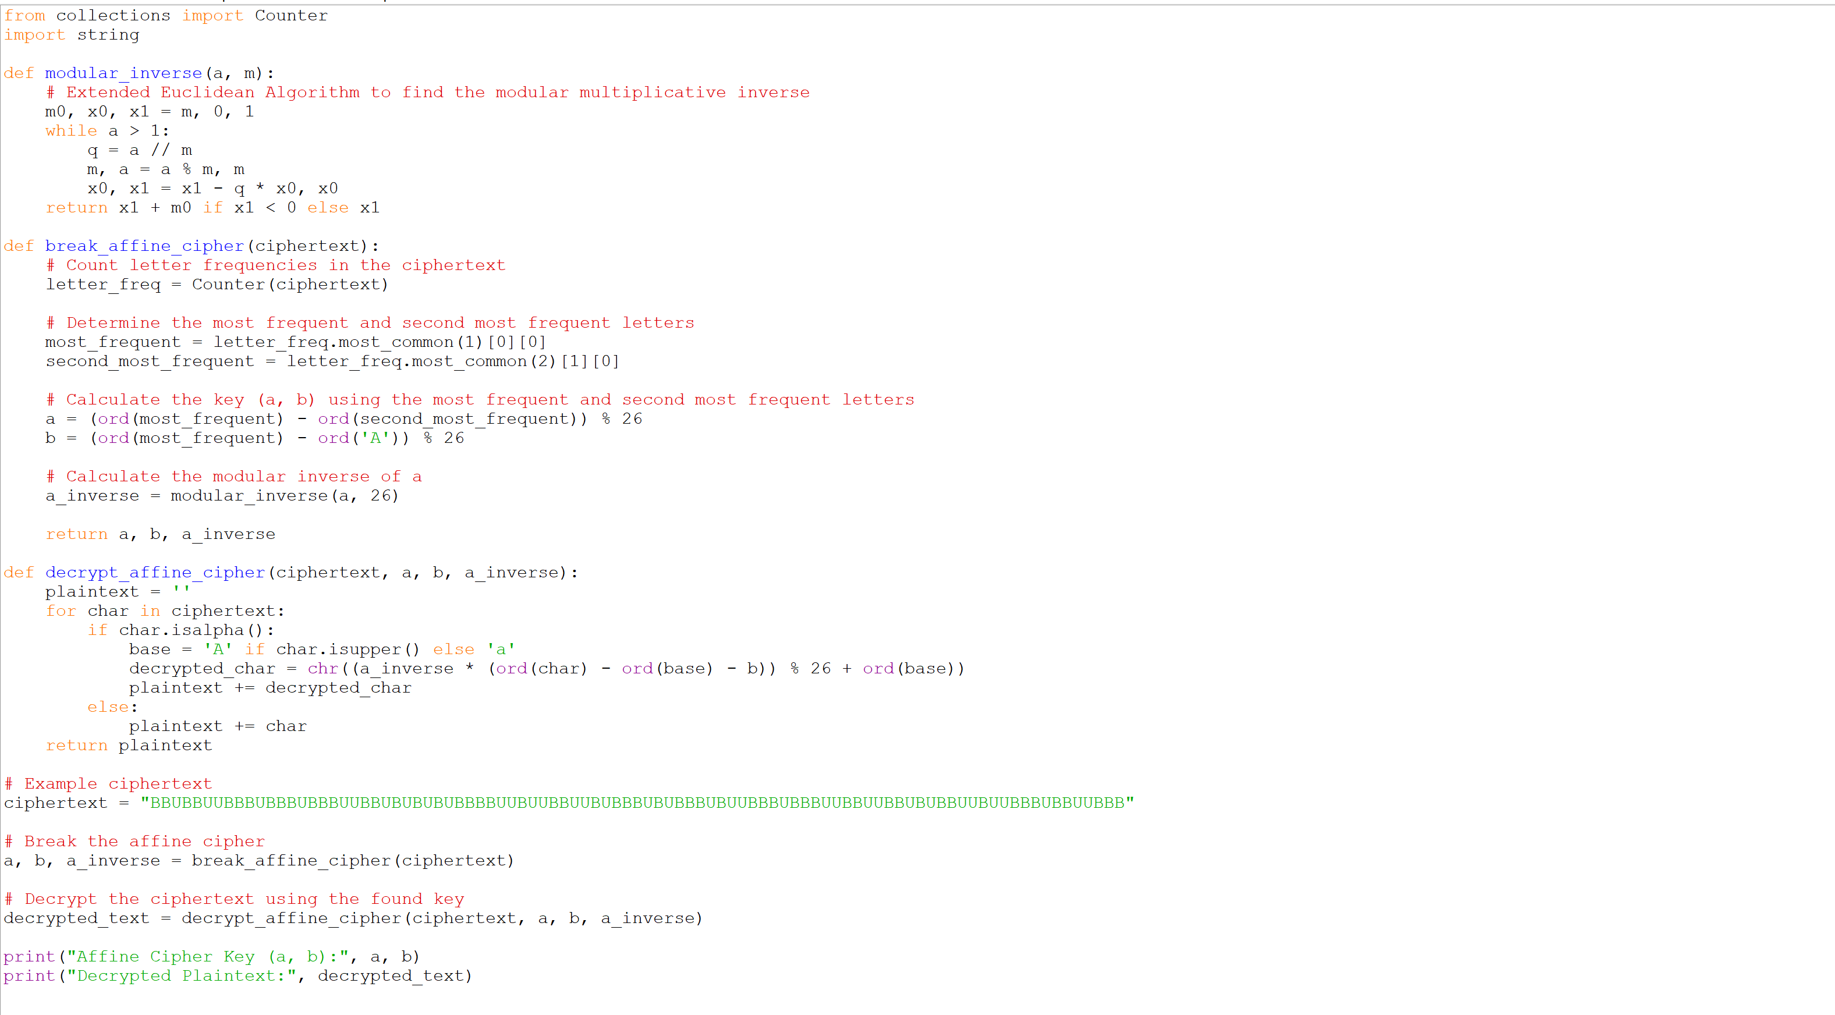



9.HILL CIPHER USING PYTHON

